Week 1
Served w/c 4th Jan, 16th Jan, 30th Jan, 13th Feb, 6th Mar, 20th Mar, 3rd Apr
Monday | Pizza Margarita  Sweetcorn  Diced Potatoes  ****  Arctic Roll and mandarins  Fresh fruit
Tuesday | Roast Chicken, Stuffing and Gravy  Medley of Vegetables  Creamed Potatoes  Pitta Bread  ****  Rice pudding and jam  Fresh fruit
Wednesday | Lasagne  Potato wedges  Crusty Bread  ****  Chocolate Cake and Chocolate Sauce  Fresh fruit
Thursday | Homemade Pork Sausage Roll  New Potatoes  Peas and Carrots  Wholemeal bread  ****  Fresh Fruit Salad and Yoghurt
Friday | Breaded Salmon Fillet  Broccoli and Sweetcorn  Chips  Crusty Bread  ****  Chocolate Muesli Krispie  Fresh fruit

Week 2
Served w/c 9th Jan, 23rd Jan, 6th Feb, 27th Feb, 13th Mar, 27th Mar
Monday | Macaroni Cheese  Broccoli  Crusty Bread  ****  Grannie’s Crunch  Fresh fruit
Tuesday | Chicken Korma  Brown Rice  Green Beans and Sweetcorn  Pitta Bread  ****  Jam Sponge and Custard  Fresh fruit
Wednesday | Minced Beef in Gravy  Creamed Potatoes  Peas and Carrots  Crusty Bread  ****  Strawberry Bun  Fresh fruit
Thursday | Sausage Pasta  Broccoli and Sweetcorn  Wholemeal Bread  ****  Treacle and Custard  Fresh fruit
Friday | Fish Fingers  Peas and Carrots  Sauté Potatoes  Crusty Bread  ****  Yoghurt and Abbey Biscuit  Fresh fruit

School Meals in North Yorkshire
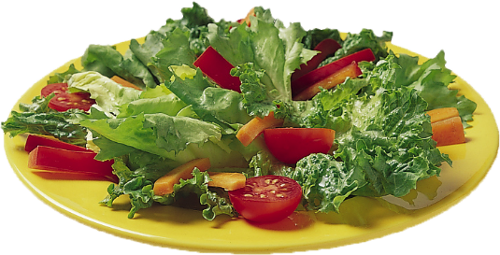
Children and young people in North Yorkshire can be confident that they are enjoying the best of British when they sit down to enjoy a school lunch provided by North Yorkshire County Council’s school meal service, SmartSolutions Catering.
All food suppliers are based in the Yorkshire region with the majority being family owned businesses. Only fresh meat and poultry is used in school lunches most of which is sourced from within the county boundary.
Half of all fruit and vegetables are sourced from the north of England and all the eggs we use are free range. They are sourced in the Yorkshire region and have received a “Good Egg Award” for our free range egg policy from the animal welfare charity Compassion in World Farming.
We use a range of fair trade products including sugar, coffee and cocoa. Gluten free items are also stocked including sausages, pasta, flour and bread and we are now using organic pasta as well.
All food served in our schools is freshly prepared from scratch every day.

CONTACT US
June Taylor, Primary School Manager
County Hall, Northallerton, North Yorkshire, DL7 8AE.
Tel: 01609 536889
Email: june.taylor@northyorks.gov.uk
If you would like this information in another language or format such as Braille, large print or audio, please ask us.
Tel: 01609 780 780
Email: customer.services@northyorks.gov.uk

Sheriff Hutton Primary School

Spring Menu 2017
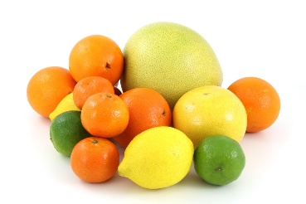

This term we are running a two week menu.

The school’s ‘Food Council’ helped to design our final menu alongside the catering staff and in line with North Yorkshire’s recommendations.

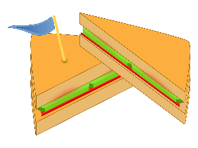
We will continue to offer a ‘cold option’ throughout the summer term – this includes a choice of sandwiches, pasta salad or cous cous, lettuce and vegetable sticks (carrot, cucumber, pepper etc). The dessert is as listed on the following menu.

