Week 1
Served w/c: 9th Jan, 22nd Jan, 5th Feb, 26th Feb, 12th Mar, 26th Mar
Monday | Fish Fingers  Peas and Sweetcorn  Chips  Crusty Bread  ****  Shortbread Finger and Yoghurt  Fresh fruit
Tuesday | Bangers and Mash with Gravy  Carrots and Broccoli  Wholemeal Bread  ****  Chocolate Cake and Chocolate Sauce  Fresh fruit
Wednesday | Roast Chicken, Stuffing, Gravy  Mixed Vegetables  Roast Potatoes  Pitta Bread  ****  Lemon Drizzle Cake and Custard  Fresh fruit
Thursday | Minced Beef Wrap  Savoury Rice and Vegetables  ****  Carrot Cake Muffin  Fresh Fruit
Friday | Organic Burger in a Homemade Bun  Peas and Sweetcorn  Potato Wedges  ****  Flapjack  Fresh fruit

Week 2
Served w/c: 15th Jan, 29th Jan, 19th Feb, 5th Mar, 19th Mar
Monday | Cheese and Tomato Pizza  Peas and Sweetcorn  Potato wedges  ****  Grannie’s Crunch  Fresh fruit
Tuesday | Chicken Korma  Brown Rice  Green Beans and Carrots  Pitta Bread  ****  Treacle Sponge and Custard  Fresh fruit
Wednesday | Roast Pork and Gravy  Mashed Potatoes  Broccoli and Swede  Crusty Bread  ****  Digestive Biscuit, Cheese and Grapes  Fresh fruit
Thursday | Spaghetti Bolognaise  Peas and Carrots  Crusty Bread  ****  Chocolate Orange Brownie and Custard  Fresh fruit
Friday | Battered Fish  Chips and Vegetables  Wholemeal Bread  ****  Oat Cookie and Orange Wedge  Fresh fruit

School Meals in North Yorkshire
Children and young people in North Yorkshire can be confident that they are enjoying the best of British when they sit down to enjoy a school lunch provided by North Yorkshire County Council’s school meal service, SmartSolutions Catering.
All food suppliers are based in the Yorkshire region with the majority being family owned businesses. Only fresh meat and poultry is used in school lunches most of which is sourced from within the county boundary.
Half of all fruit and vegetables are sourced from the north of England and all the eggs we use are free range. They are sourced in the Yorkshire region and have received a “Good Egg Award” for our free range egg policy from the animal welfare charity Compassion in World Farming.
We use a range of fair trade products including sugar, coffee and cocoa. Gluten free items are also stocked including sausages, pasta, flour and bread and we are now using organic pasta as well.
All food served in our schools is freshly prepared from scratch every day.

CONTACT US
June Taylor, Primary School Manager
County Hall, Northallerton, North Yorkshire, DL7 8AE.
Tel: 01609 536889
Email: june.taylor@northyorks.gov.uk
If you would like this information in another language or format such as Braille, large print or audio, please ask us.
Tel: 01609 780 780
Email: customer.services@northyorks.gov.uk

Sheriff Hutton Primary School

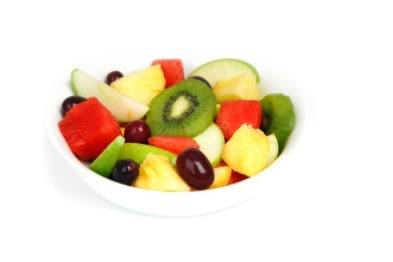

Spring Menu 2018

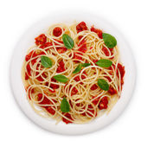

This term we are running a two week menu.

The school’s ‘Food Council’ helped to design our final menu alongside the catering staff and in line with North Yorkshire’s recommendations.

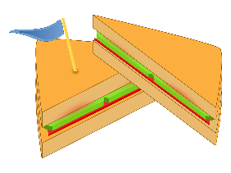
We will continue to offer a ‘cold option’ throughout the summer term – this includes a choice of sandwiches, pasta salad or cous cous, lettuce and vegetable sticks (carrot, cucumber, pepper etc). The dessert is as listed on the following menu.

